Name: Zuriel G. Montallana

Year/Block: BSIT3-B1

**LabAct1**

1. List 3 protocols appearing in the protocol column in the unfiltered packet-listing window in step 7 above. Then, briefly describe the function of each protocol. (5pts)

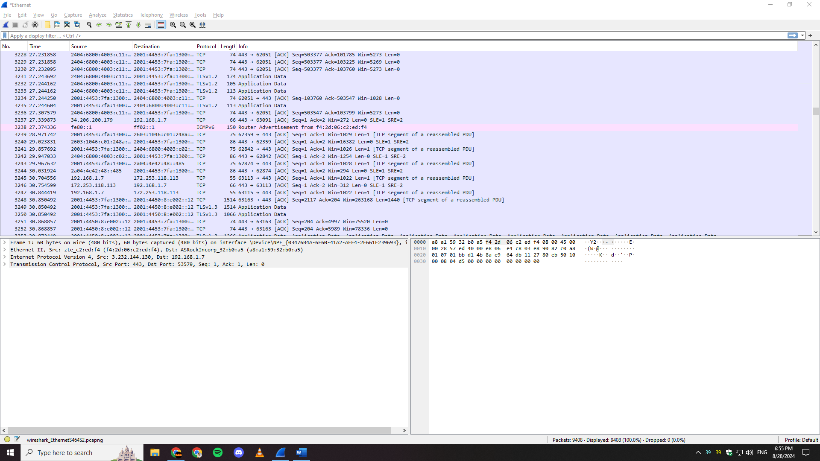

1. TLSv1.2 - Secures communication via encryption, widely used but supports older, less secure cryptographic methods.

2. ICMPv6 - Handles error reporting, diagnostics, and essential network operations in IPv6.

3. TLSv1.3 - Provides secure, encrypted communication with faster performance and stronger security than previous versions.

2. How long did it take from when the HTTP GET message was sent until the HTTP OK reply was received? (By default, the Time column value in the packet-listing window is the amount of time, in seconds, since Wireshark tracing began. To display the Time field in time-of-day format, select the Wireshark Viewpull down menu, select Time Display Format, then select Time-of-day.) (5 pts)

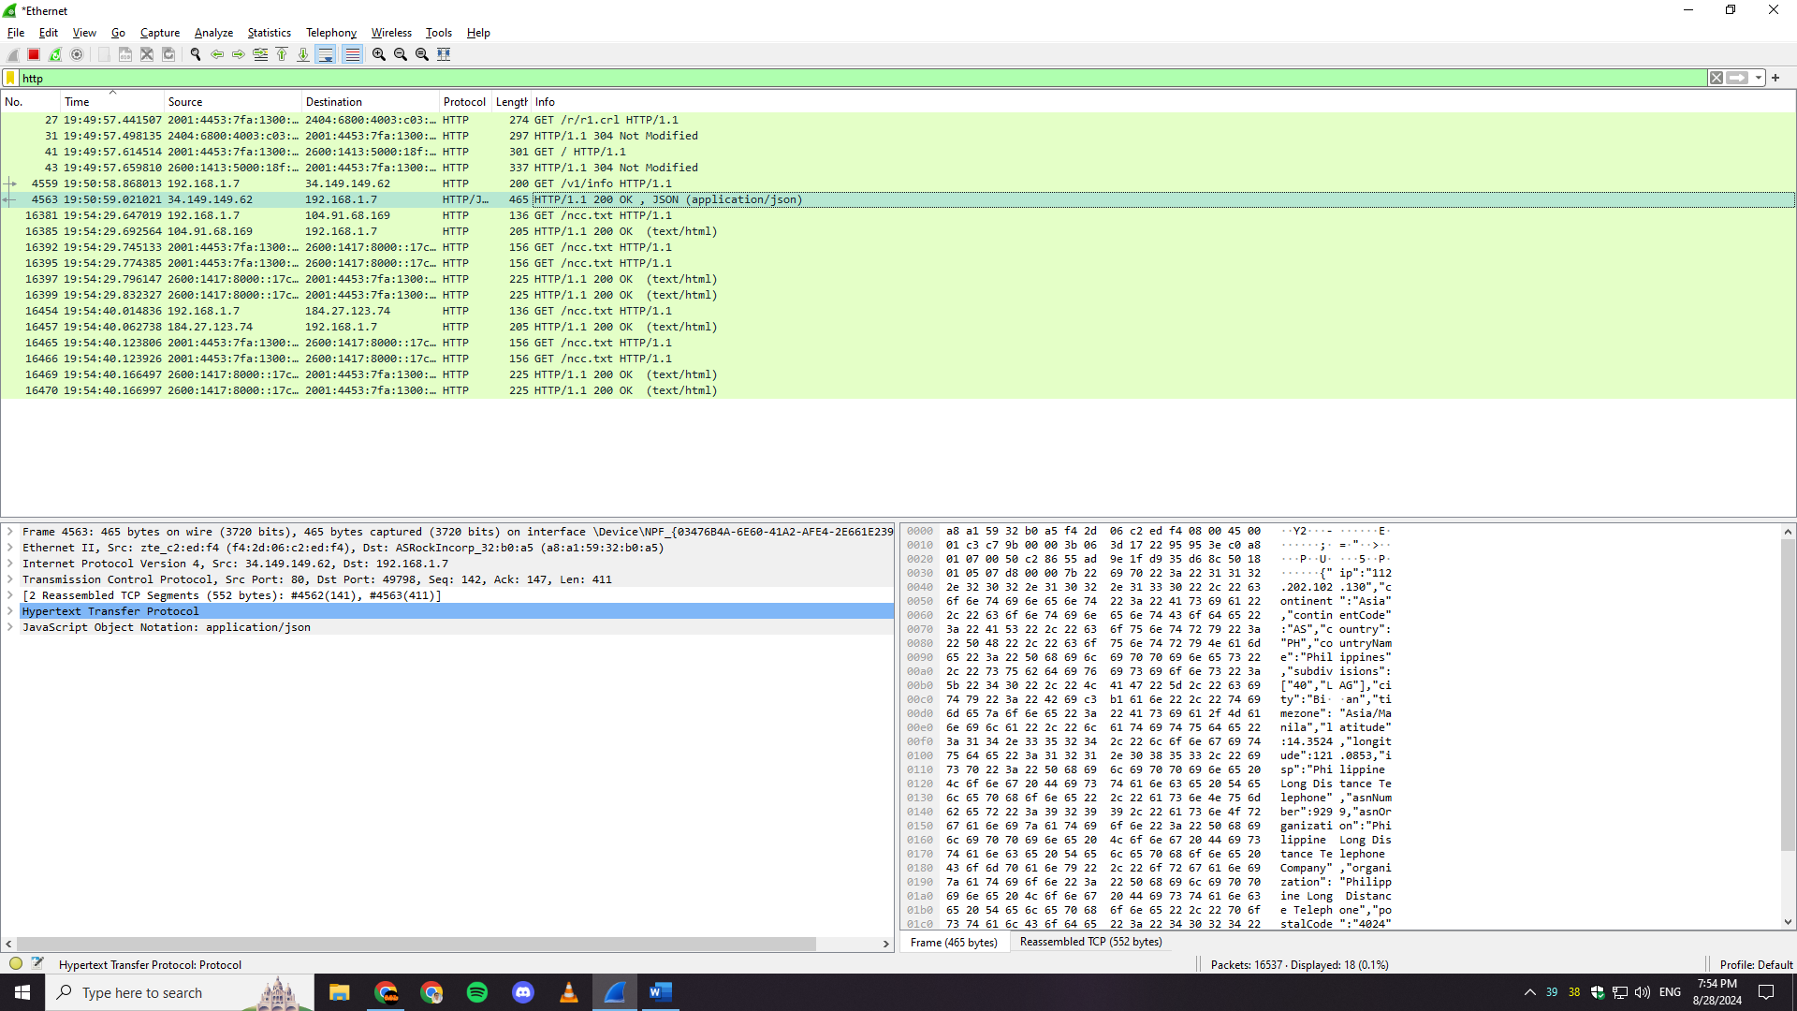

The HTTP GET request was sent at 19:49:57.615328, and the server responded with an HTTP 200 OK at 19:49:57.690143. This means it took about 0.075 seconds for the server to process the request and send back the response.

3. What is the Internet address of (also known as www-net.cs.umass.edu)? What is the Internet address of your computer? (5 pts)

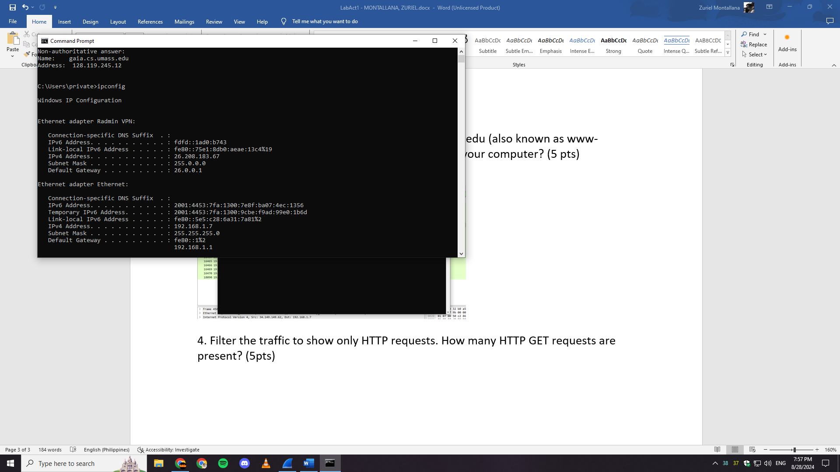

I opened cmd and then first type “nslookup gaia.cs.umass.edu”. The Internet address of gaia.cs.umass.edu is 128.119.245.12, While my computer's IP address is 192.168.1.7 with an IPv6 address of 2001:4453:7f8a:1300:9ecb:fp04:99e0:1b6d using ipconfig on the command.

4. Filter the traffic to show only HTTP requests. How many HTTP GET requests are present? (5pts)

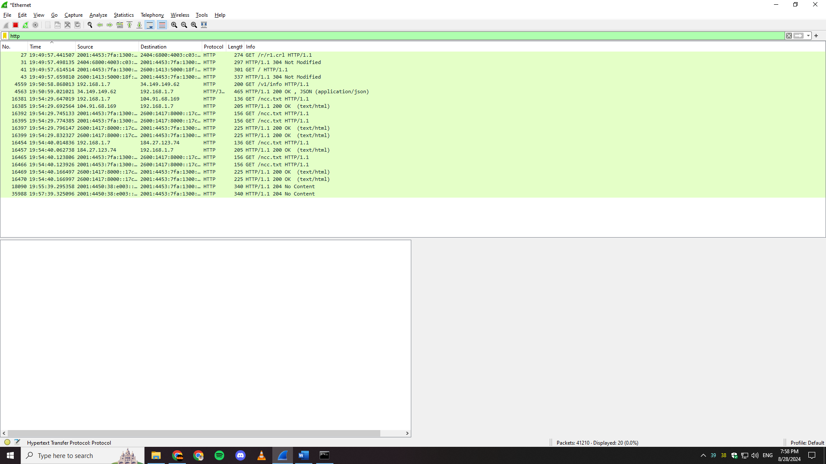

After typing “http” on the filter bar, it displayed all protocols which are only http and there are four HTTP GET requests present. These are shown in packets numbered 2, 5, 11, and 31.